Invoice POD Status Analysis & Grouping
EDA:
📊 Data Structure
• Number of Records:
• Number of Fields/Columns:
POD sheet:
Contain 27 columns with grouping the new column:
- CALDAY: Snapshot Date.
- INV_NUM: Most important column because it’s unique and we need to do calculation and measure like count.
- DELV_NUM: Picking ticket.
- POD 1 Date: Operation team submit it.
- POD 1 User: Who submits it? Like employe number.
- POD 2 Remark: Any notes.
- POD 2 Date: Finance team gets submitted approve.
- CUST_CHAIN_NAME (unique).
- SO_num: Sales order number.
- SOLD_TO: main, primary customer account one like panada.
- Ship_to: Branch and it can be more than one place multiple; customer chooses the place.
- SALES_OFFICE: Destination, where did he go or get? lookup with sales office name.
- PLANT: Source, from where it comes.
Customer Master sheet:
The main where we bring important data and include primary keys
Contain 12 columns:
- CUSTOMER: Same as SOLD_TO.
- Customer_class
- Concate: is combination between Customer_group_code and Customer_class_code and unique.
- ACCOUNT_GROUP: it can be whether for Bco for example Z04, Z05…etc. or NGL for example Z019.
- Creation date: customer sign-in in system date.
- CUST_GROUP: it’s common with channel Mapping sheets by concate.

Channel Mapping sheet:
Contain 9 columns:
- Customer_group_code: There’s too many of them identify in system as
  - Traditional Trade (10)
  - Organized Trade (20)
  - HTS (40)
  - Food Servies (50)
  - Auto (60)
  - Health and beauty (30), not using.
Customer Chain Mapping sheet:
Contain 3 columns:
All unique values like CUST_CHAIN_CODE (we are needing it to link in Customer master) and CUST_CHAIN_NAME.
Sales Office Mapping:
Contain 2 columns:
- Simplfied_Name: Branch Name
- Simplfied_Code.
Step 1: Xlookup (Data Preparation & Joining)
Goal of this step: Combine all important & needed columns into one single table before starting calculating from main sheet (POD= Prove of delivery).
- Invoice Date | - When invoice entered system, already exist in POD sheet.
- Invoice Type | - Already exist in POD sheet.
- Sales Office Name | - Need to do xlookup from Sales Office Mapping using Sales_Office_Code as reference.
- Simplified Channel | - For this column I needed to bring concate column as a reference by combining (grouping) it in Customer Master sheet from Channel Mapping sheet (Customer_Group_Code+Customer_Class_Code), then I use it as reference to look for simplified channel.
- Customer Chain | - Its unique.  - Need to do lookup From Customer Master using CUSTOMER (SOLD_TO = the main number and its unique) as reference.
- Customer Name | - I need to do xlookup from Customer Master sheet using CUST_CHAIN_CODE as reference.

Step 2: IF Statements (Logic for KPIs)
Goal of this step: Do calculations to define POD Date (1, 2, 1&2) exist or not based on condition (available date).
Invoices with POD 1 – Complete: Code basically check if POD 1 <> Null then bring 1 and mean date is available (complete) else if not gives you 0 (Incomplete).
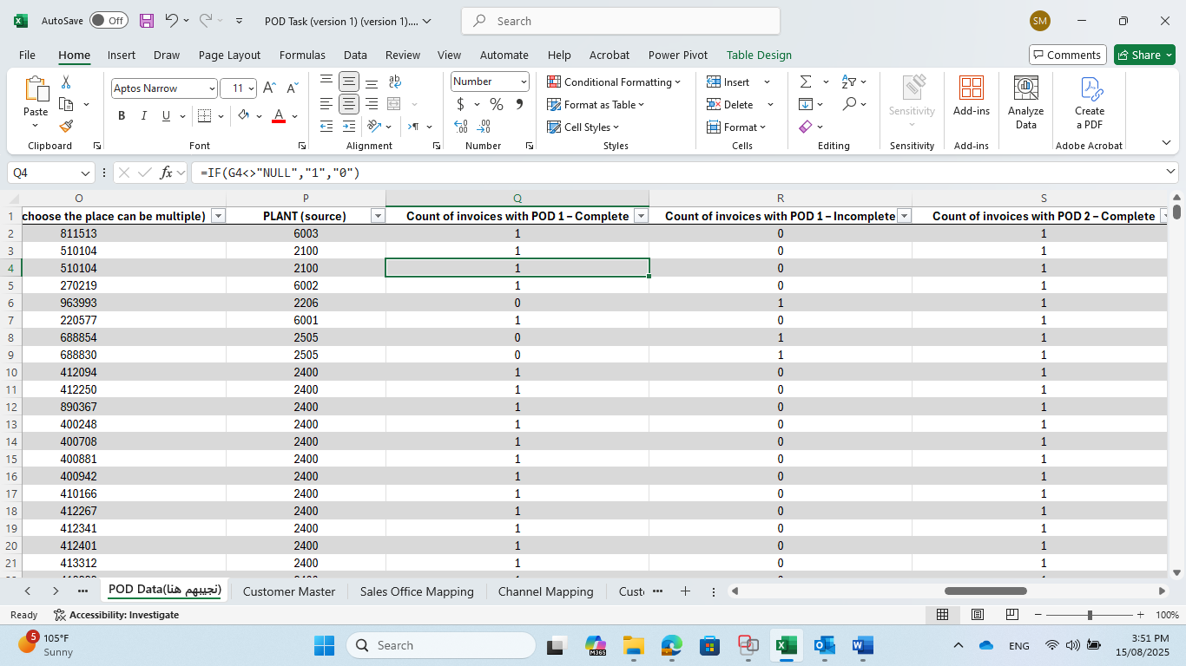

Invoices with POD 1 – Incomplete: Depend on previous column (invoices with POD 1 – Complete) so he checks if value 1 that’s mean there’s date and we don’t need it, so he didn’t put, else if value 0 mean there’s no date = incomplete so it shows 1.

Invoices with POD 2 – Complete: check if POD 2 <> Null then bring 1 and mean date is available (complete) else if not gives you 0 (Incomplete)→not exist in data.
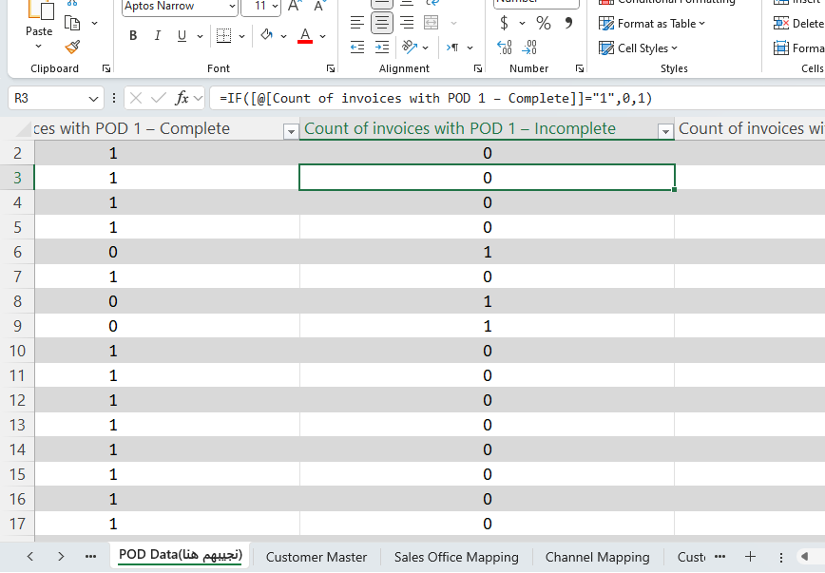
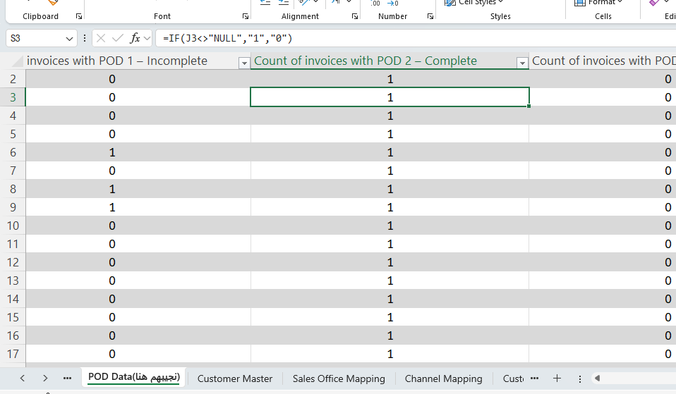

Invoices with POD 2 – Incomplete: Depend on previous column (invoices with POD 2 – Complete) so he checks if value 1 that’s mean there’s date and we don’t need it, so he didn’t put, else if value 0 mean there’s no date = incomplete so it shows 1.
*Note: all dates in POD 2 are available so it shows all 0.

Invoices with both POD 1 & POD 2 – Complete: I used isnumber() formula to
Check for two conditions: 1 - POD 1 date is number and available? AND
2 – POD 2 date is number and available? gives 1 else 0.
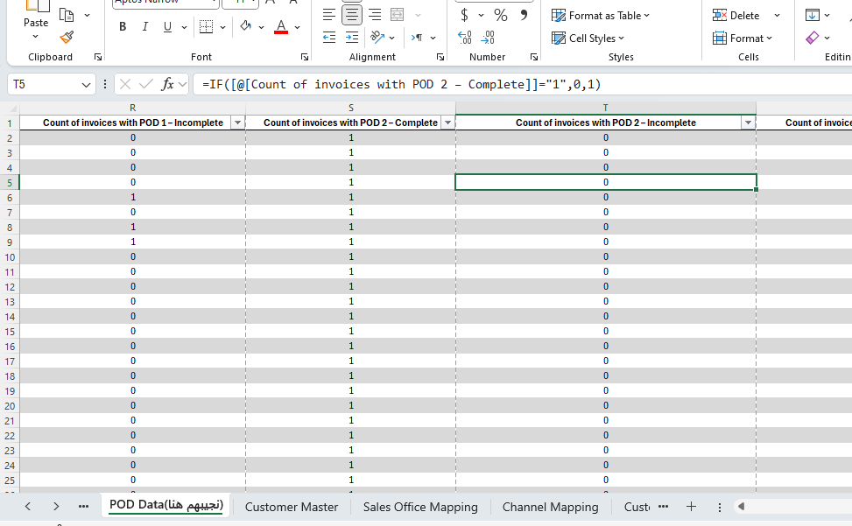
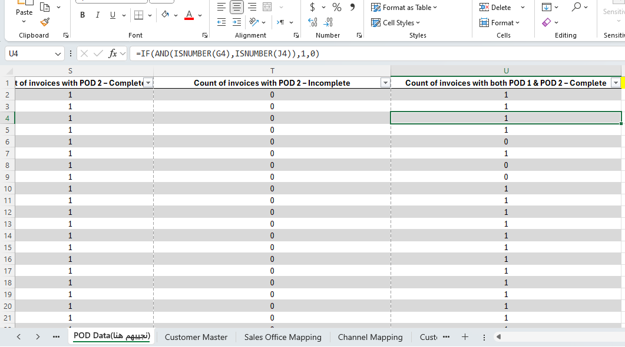

Step 3: Do report to summary and highlight important information by grouping and do the counts using PivotTable.
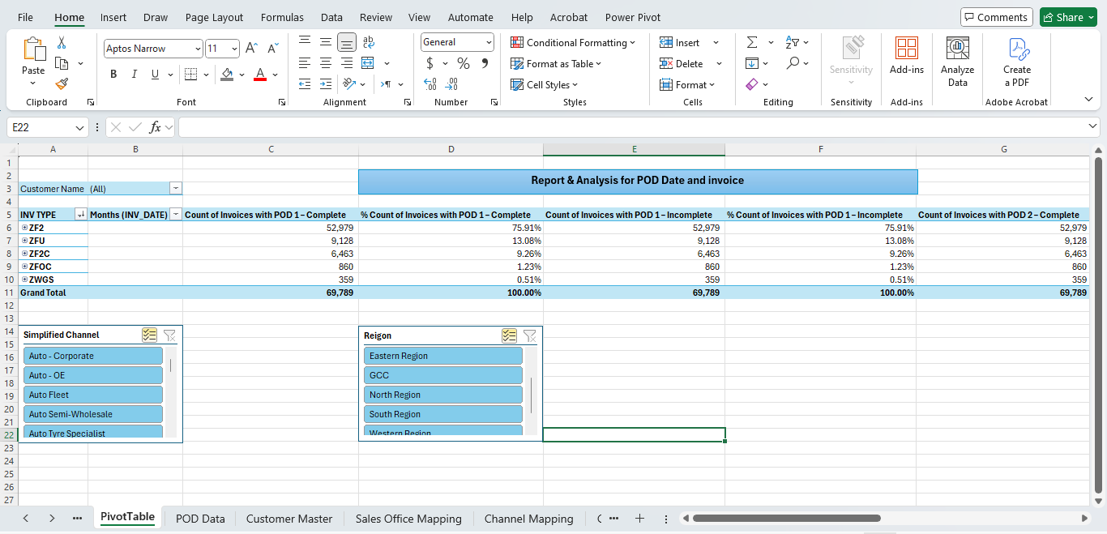

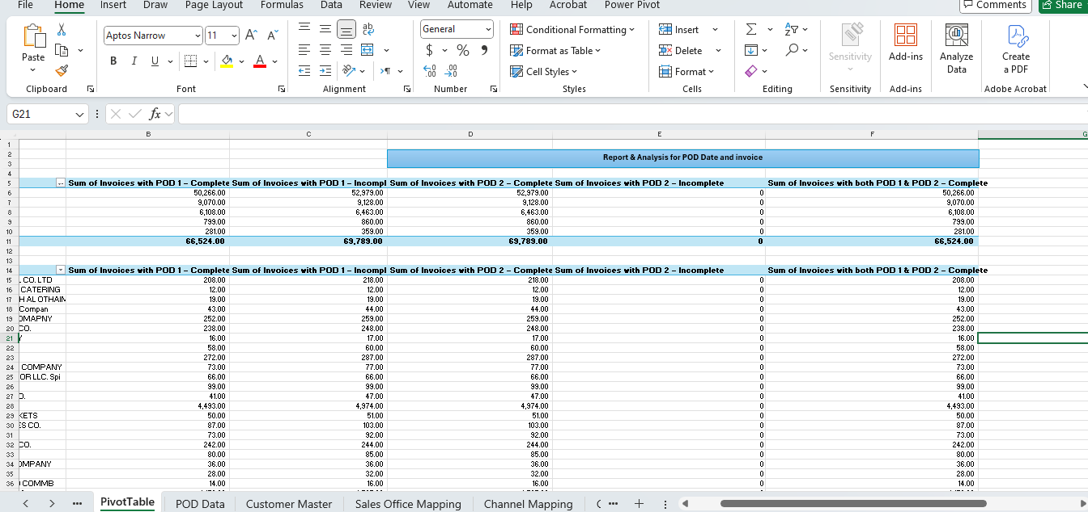

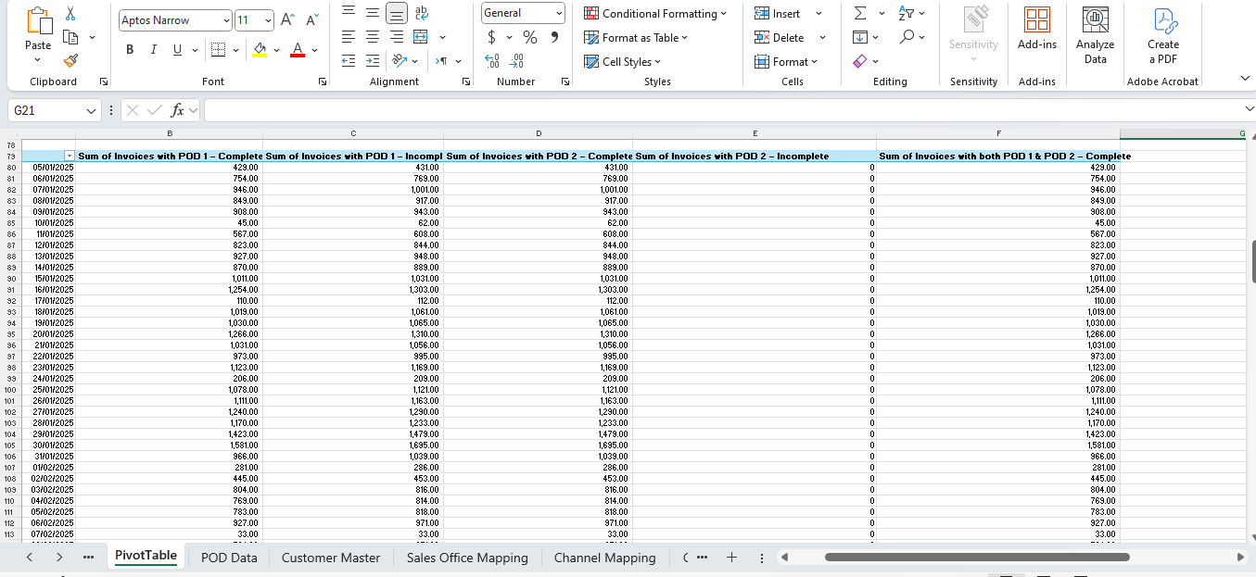

Phase two:
To create the following calculations using DAX or M Query:
- Count of invoices with POD 1 – Complete code:
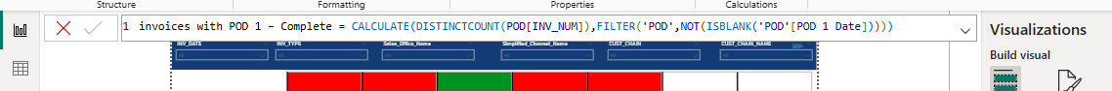
- Count of invoices with POD 1 – Incomplete code:
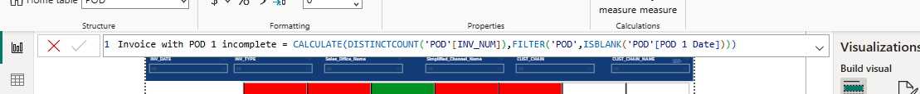

- Count of invoices with POD 2 – Complete code:
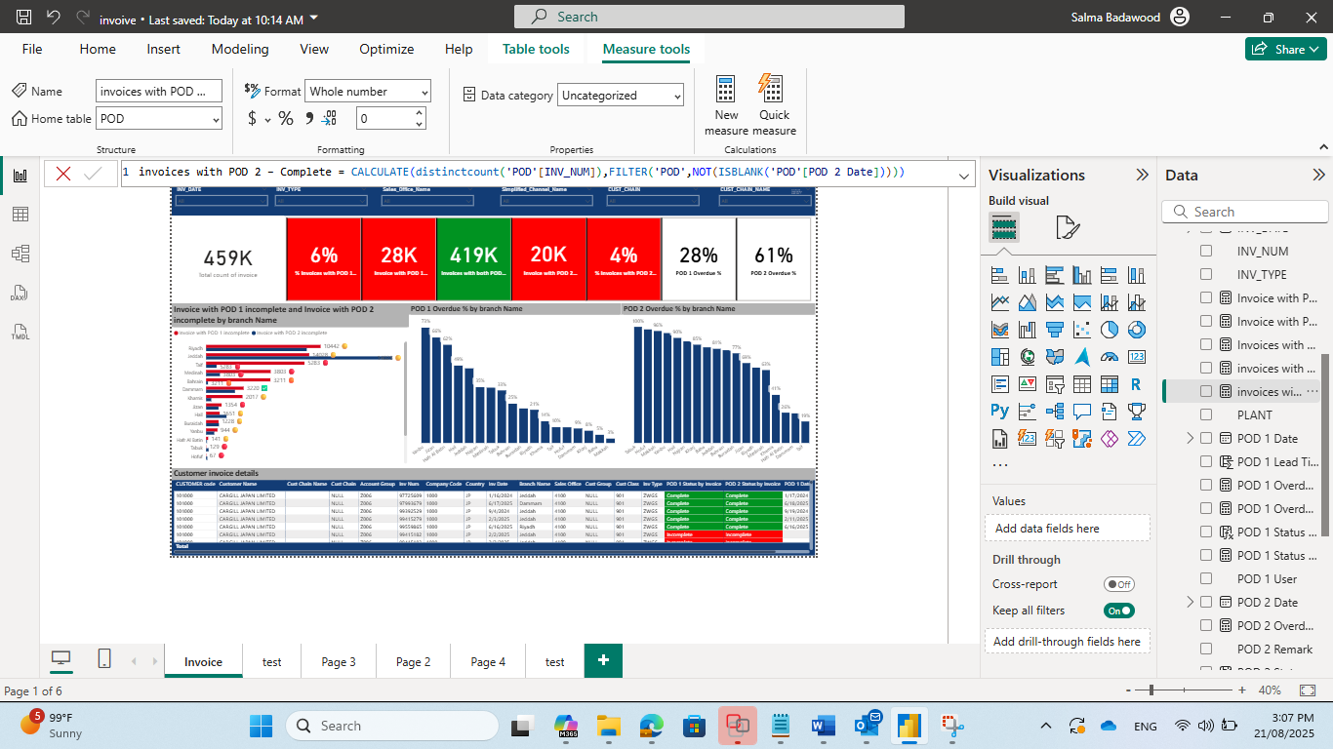
- Count of invoices with POD 2 – Incomplete code:
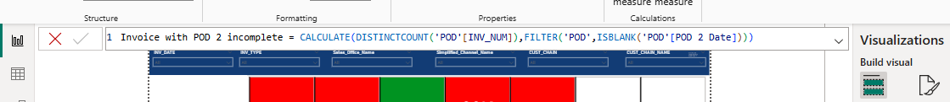

- Count of invoices with both POD 1 & POD 2 – Complete code:
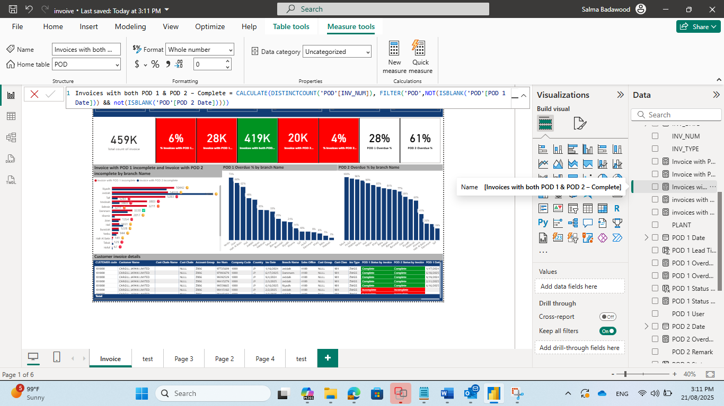

- Power BI Visualization
Once the Excel analysis is complete, we will move to Power BI to build a dynamic dashboard that visualizes the results. The dashboard should include:
- Filters for each grouping dimension
- Visual breakdowns of POD completion status
- Highlighting of areas with high POD incompletion rates
- The mentioned Grouping

The Dashboard discusses incomplete invoice issues for operation team at a customer level for both POD1 & POD 2, to try to solve lateness in submitting or not submit at all and track invoice state starting by POD 1 operation team then POD 2 finance team.

- Main KPI:
KPI | Explain? Objective?
Total count of invoice | Describe the total count of invoice so we can compare results with it
Invoice with POD 1 incomplete  and percentage of it % Invoices with POD 1 Incomplete. | Describe POD 1 Statue and check POD 1 Date, does it is incomplete?  *Incomplete = null date, no available.  Then divide incomplete Invoice on Total Count to get percentage of it.
Invoice with POD 1 - Complete | Describe POD 1 Statue  and check POD 1 Date does it is complete or not.  *Complete = available date.
Invoices with POD 2 – Complete | Describe POD 2 Statue and check POD 2 Date does it is complete or not.  *Complete = available date.
invoices with POD 2 – Incomplete and percentage of it % Invoices with POD 2 Incomplete. | Describe POD 2 Statue and check POD 2 Date, does it is incomplete?  *Incomplete = null date, no available.  Then divide incomplete Invoice on Total Count to get percentage of it.
Invoices with both  POD 1 & POD 2 – Complete | Give you A comprehensive broad overview of complete invoice for both POD 1 and POD 2.
POD 1 Lead Time | Describe Date different between invoice number and POD 1 Date by Days.  And we need to shortcut time of the pod as fast as possible to collect from customer.
% Overdue  POD 1 > 7 Days | Describe overdue than 7 days based on lead time of POD 1
% Overdue  POD 2 > 3 Days | Describe overdue than 7 days based on lead time of POD 1 , POD 2 different between them.  *Note: Complete POD 2.
POD between 1-2 Lead Time | Describe Date different between POD 1 Date and POD 2 Date by Days.
Threshold – helpful tool for % of POD 1 and 2 Incomplete Invoices. | We need it to check statue by percentage % of POD 1 and 2 Incomplete Invoices.  As follow :  SWITCH(  TRUE(),  IncompleteRate >= 0.2, "🔴",  IncompleteRate >= 0.15, "🟠",  IncompleteRate >= 0.05, "🟡",  TRUE(), "✅"

Salma Mohammed Badawood

